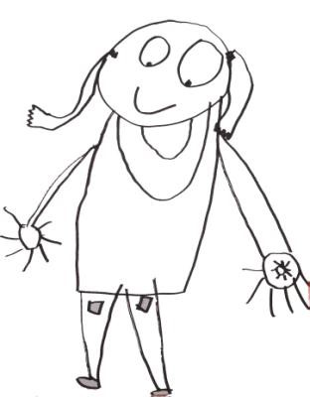

Greenbank Pre

School

Parental Involvement Policy

Greenbank Pre School
Edinburgh Greenbank Parish Church of Scotland
Braidburn Terrace
Edinburgh EH10 6ES

SPPA Registration No: 0923
Charity No SCO11325

Policy Number GBPSPOL18

Parental Involvement Policy

Greenbank Pre School will:

- Encourage parents or carers and their children to visit Pre School as a family before applying for a place for their child.

- Offer a flexible approach to all parents/carers to allow for a settling in period when starting and for all concerned to become used to the Pre School’s routines and policies.

- Welcome new parents/carers and help them to become familiar with the routine of the Pre School and guidelines of good practice. The Pre School recognises that it is difficult for new parents/carers to understand how the Pre School operates unless time is specifically given to this task.

- Welcome the contributions of all parents/carers whatever form these might take and ensure they have opportunities to contribute their skills, knowledge and interest.

- Involve parents/carers in the progress of their child formally and informally and work with them in sharing all records concerning their child.

- Inform parents/carers that the Pre School has adopted a number of policies to provide a quality environment.

- Ensure that parents/carers are kept fully informed about meetings and training and that these will be held at various times to take into account individual family needs.

- Ensure that parents/carers are aware of how any queries, complaints or suggestions can be made.

- Ensure that parents/carers are able to talk and discuss personal matters relating to their child, in confidence, on a daily basis if required.

- Encourage parents/carers to play an active part in the running and management of the Pre School.

- Provide opportunities for parents/carers to participate in the Pre School’s activities, to learn about the Pre-School curriculum and the importance of play in the child’s development both in the Pre School and at home.

- Make every effort to provide translation service or interpreters as needed for parents/carers whose first language is not English.

- Invite parents and carers to participate in the sessions and not confine their role to domestic duties.

- Be flexible enough to cope with adults who have special needs.

- Every parent and carer should be helped to participate as much as they are able to do. No-one should be made to feel a burden or a nuisance.

- Adults who are not members of the PVG scheme will not be asked to take a child or a group of children to the toilet or into an area away from staff.

A Guide to Snack Preparation is provided as an appendix.
All staff and committee members will have a working knowledge of this policy.
We acknowledge the guidance from SPPA in drawing up this policy

Date of review January 2020 Name Joan Ritchie

APPENDIX

Guide to Snack Preparation

Date last updated: 29/01/2020 22:36

Intro

Snack preparation is one of the areas where parents can help. This is, hopefully, a useful guide to preparing snack at Greenbank preschool.

Where's Everything?

Equipment

Picture of kitchen showing location of:
- Knives - drawer
- Chopping board
- Children's plastic crockery and cups - cupboard, lower shelf
- Serving Plates - cupboard, upper shelf

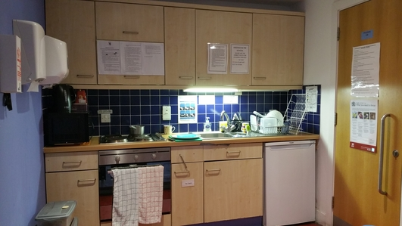
Knives

Chilled Foods & Milk
Kid's Plates & Cups

Serving Plates

Dry Stores

Food and Drink
- Fruit, vegetables, and dairy items are stored in the fridge
- Dry food items e.g cream crackers, bread sticks, rice crackers are kept in the large plastic containers in the storage cupboard
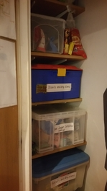

What Do We Do?

Prepping the snacks
Cut up any fruit and vegetables and prepare any savoury snacks. Serve on the lower counter.
- Be aware of any allergies/dietary requirements e.g. dairy, nut, vegetarian, vegan and know of alternatives.

Prepping the drinks
- Fill up the jugs with milk and water (latter from the cold tap).

What are we having today?
Use the little board to show what snacks they are having and how many pieces they can have of each.

Clean hands
Remind the children they need to wash their hands prior to snack.

Tracking snackers
Remind the children to put their wooden name circles into the basket if they are having snack.
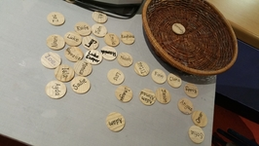

Whoops what a mess
Encourage the children to clean up any spillages or messes themselves.

Snackers tidy up
The children are encouraged to rinse their plates and cups in the little sink on the serving counter and then place them on the drying rack beside it.

Other Information

Allergies
There is a list of children with allergies/special dietary requirements to be aware of. It has photos to help identify children to ensure they do not consume items that are on their list.

Hints & Tips
- Seconds: when they ask for seconds you can say that we need to leave it until everyone has had snack otherwise there's not enough to go around but they can come back towards the end of snack time and see if there's any leftovers.

Other Information

Other information that is posted in the kitchen.

Food & Hygiene Routines and Procedure
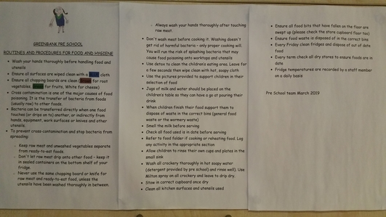

Further Notes for Parent Helpers on Snack Duty
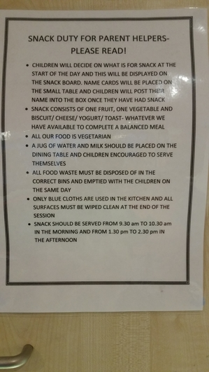

Cleaning Cloth Colour Code
